# File permissions in Linux

## Project description

In this lab, some of the files and directory have their permission set wrong for their uses.

We need to fix this issue so only authorized users may have access to the file for security.

## Check file and directory details

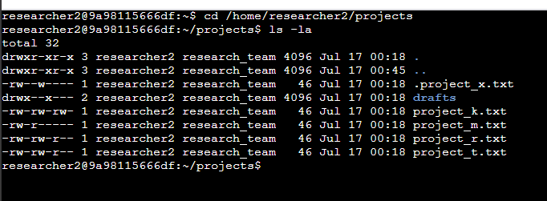

## Describe the permissions string

Linux shows permissions in User, Group, and Other order, with each having read, write, execute permissions. For instance, project_k.txt has a permission of -rw-rw-rw-, which states user, group, and other has read and write permissions of the file.

## Change file permissions

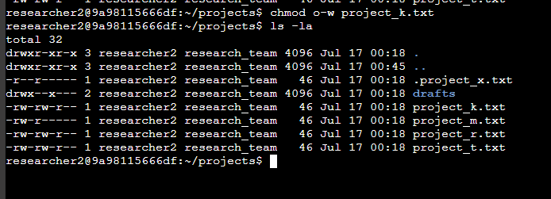

Changing file permission can be done with chmod. In this case we took out the write permission of other, so they can only read project_k.txt

## Change file permissions on a hidden file

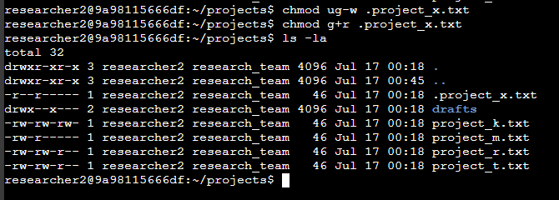

.project_x.txt is a hidden file that cannot be edited but only readable by the user and group.

This was done with removing w permissions from user and group, then adding read permission to the group.

## Change directory permissions

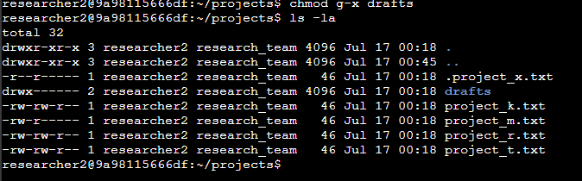

Dir drafts is only for the user, and the user should only be able to have execute permission.

So in this case x was taken out from group.

## Summary

To summarize, in this lab, I have used ls -la command to view the contents and permission of the files and directory, and used chmod command to make changes to the permission.